Problem no:01
Problem name: Find length of a string using function.
Code:
#include <stdio.h>
int main()
{
char s[100];
int i,length;
printf("Enter a string:");
gets (s);
length=strlen(s);
printf("Length=%d",length);
}
Output:
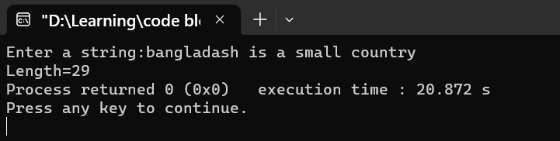

Problem no:02
Problem name: Find length of a string without using function.
Code:
#include <stdio.h>
int main()
{
char s[100];
int i,count=0;
printf("Enter a string:");
gets (s);
for(i=0;s[i]!='\0';i++)
{
count++;
}
printf("Length=%d", count);
return 0;
}

Output:
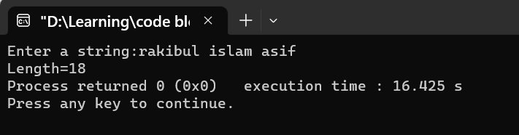

Problem no:03
Problem name: Find lowercase of a string using function.
#include<stdio.h>
int main()
{
char s1[100];
char s2[100];
printf("Enter two string:");
gets(s1);
printf("Enter two string:");
gets(s2);
int length=strlen(s1);
strlwr(s1);
strlwr(s2);
printf("lowercase=%s\n",s1);
printf("lowercase=%s",s2);
}
Output:
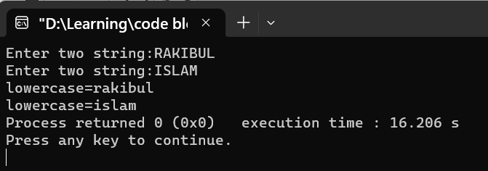

Problem no:04
Problem name: Find lowercase of a string without using function.
#include <stdio.h>
int main()
{
char s[100];
int i;
printf("Enter any string : ");
gets(s);
for(i=0;s[i]!='\0';i++)
{
if(s[i]>='A' && s[i]<='Z'){
s[i]=s[i]+32;
}
}
printf("Lowercase =%s",s);
}
Output:
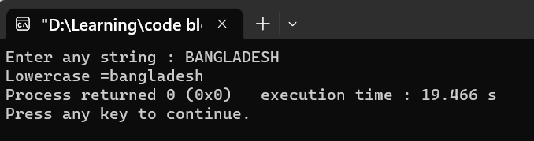

Problem no:05
Problem name: Find uppercase of a string using function.
#include<stdio.h>
int main()
{
char s1[100];
char s2[100];
printf("Enter two string:");
gets(s1);
strupr(s1);
printf("uppercase=%s",s1);
return 0;
}
Output:
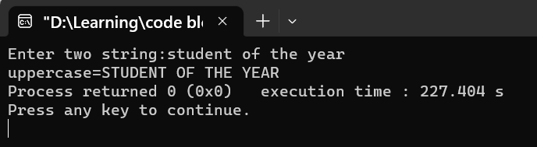

Problem no:06
Problem name: Find uppercase of a string without using function.
#include <stdio.h>
int main()
{
char s[100];
int i;
printf("Enter any string : ");
gets(s);

for(i=0;s[i]!='\0';i++)
{
if(s[i]>='a' && s[i]<='z'){
s[i]=s[i]-32;
}
}
printf("Lowercase =%s",s);
}
Output:
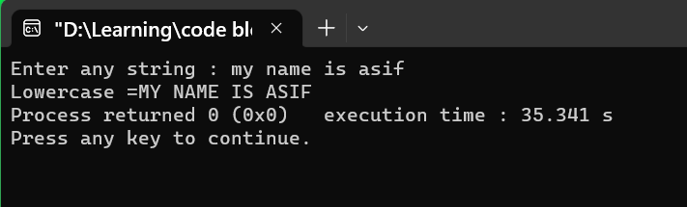

Problem no:07
Problem name: write a c program to compare two string using function.

#include<stdio.h>
int main()
{
char string1[100],string2[100];
level:printf("Enter two string:");
gets(string1);
printf("Enter two string:");
gets(string2);
char a;
a=strcmp(string2,string1);
if(a==0)
{
printf("string are equal\n");
}
else if(a<0||a>0)
{
printf("string are not equal\n");
}
goto level;
}

Out put
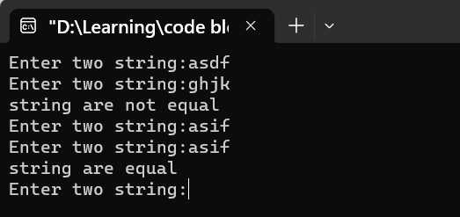

Problem no:08

Problem name: C program to count total number of vowels and consonants in a string.

#include <stdio.h>
int main()
{
char str[100];
int i,len,vowel,consonant;
printf("Enter any string: ");
gets(str);
vowel = 0;
consonant = 0;
len = strlen(str);
for(i=0; i<len; i++)
{
if((str[i]>='a'&& str[i]<='z')||(str[i]>='A'&& str[i]<='Z'))
{
if(str[i]=='a'||str[i]=='e'||str[i]=='i'||str[i]=='o'||str[i]=='u'||
str[i]=='A'||str[i]=='E'||str[i]=='I'||str[i]=='O'||str[i]=='U')
vowel++;
else
consonant++;
}
}
printf("Total number of vowel=%d\n",vowel);
printf("Total number of consonant=%d\n",consonant);
return 0;
}
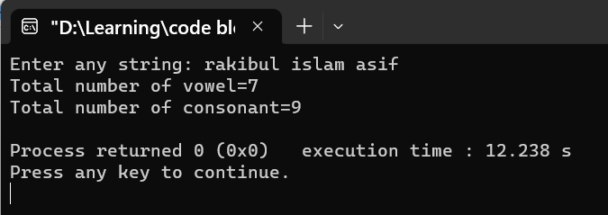

Problem no:09
Problem name: write a c program to revers of a string.
#include <stdio.h>
int main()
{
char str[100];
printf("Enter any string: ");
gets(str);
printf("Original string = %s\n", str);
strrev(str);
printf("Reverse string = %s", str);
return 0;
}
Output:
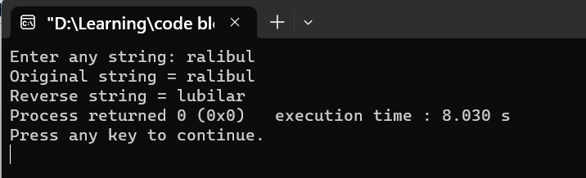


Bangladesh University of Business & Technology

Lab Report: 10
Course Title: Structured Programming Language
Lab
Code: CSE-112

Submitted By | Submitted To
Name: Rakibul islam asif  ID:22235103319  Intake:51, Section:8  Department of CSE | Name: Md. Saddam Hossain.  Assistant Professor  Department of CSE BUBT

Submission Date: 13-04-2023

